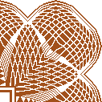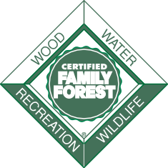

American Tree Farm System®

Qualified Inspector

This is to certify that by Authority of the American Forest

Foundation,

***<Name>***

***Inspector ID: Training Date:***

having received all proper training and meeting all eligibility requirements is qualified to inspect woodlands on behalf of the American Tree Farm System to verify that the American Forest Foundation’s Standards of Sustainability

for Forest Certification on Private Lands have been met.

Angela Wells Director, American Tree Farm System