How to Update Tree Farm Acreage
The TF acreage for any property in the ATFS database can be changed at any time to reflect property changes.
- Log into www.atfsdatabase.org
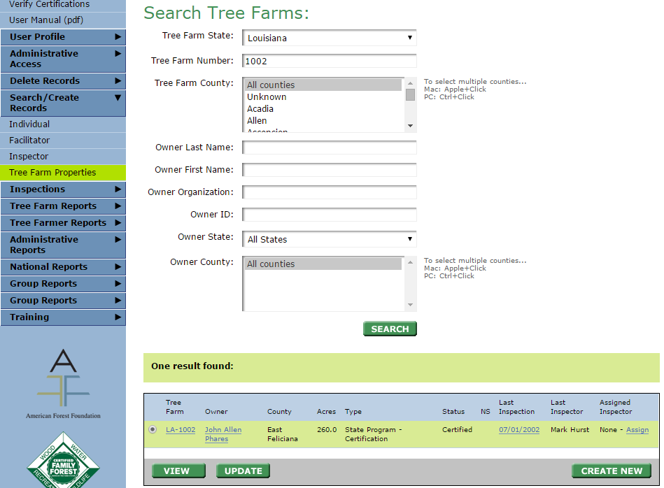
- Search for the Tree Farm whose number you want to change. Here we are doing LA-1002:
- Click the blue link with the tree farm number or you can also hit update (red box)
- A page will appear where you can change owners, click next.
- The next page will take you to the property details, all of which can be updated. At the bottom of the page you will see the acreage information. See image below
- Hit update and this portion of the page will expand so you can change acreage. Once finished, hit okay then next.
- Hit confirm so that the information is saved.
