How to Update Inspector’s Training
Committee members with District Chair and State Administrator access to the database have the capability of entering inspector training and subsequently updating it. Updating training also included marking an inspector from active to inactive or vice versa. Inspector training updates can be done easily:
- Search for the inspector by name or ID. The image below shows a search for an inspector by their ID
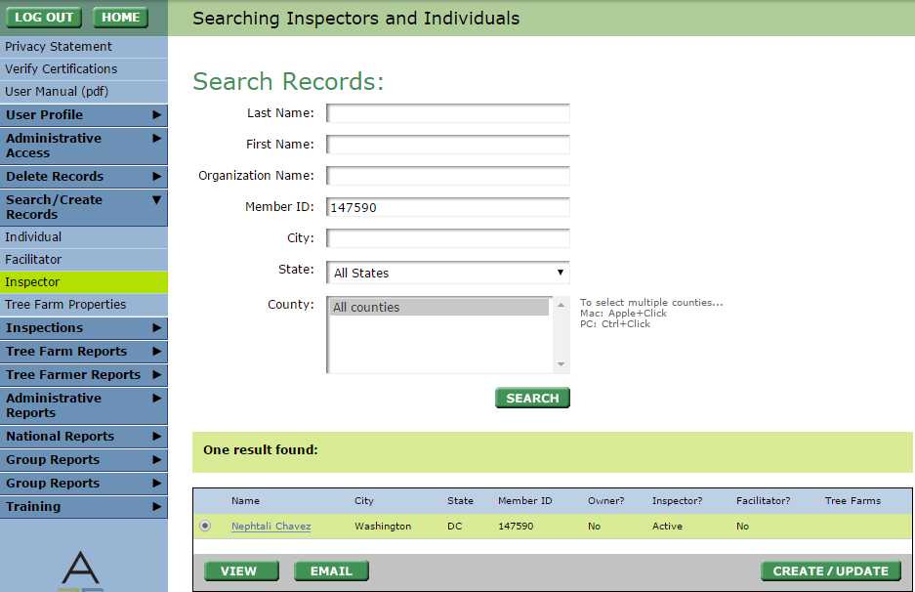
4
3
2
1
- Hit Create/ Update in the lower right
- You will see fields for their username, password, and hint. Below that you will see training related information. You may change any of these fields. Note: When updating Training information be sure to hit the green training button so that a history of training can be kept.
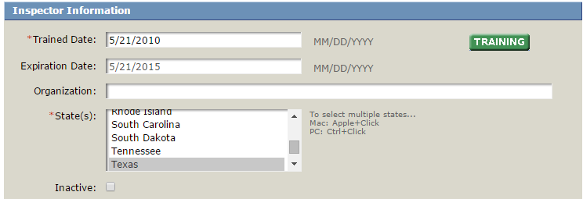
Can mark as inactive with this box
- Hit update

