How to Download Multiple 004 PDFs from ATFS

The ATFS database now has the capability of downloading multiple assigned or unassigned pre-populated 004s straight to your computer. If you are downloading more than one of these forms at a time, it will be downloaded as a zip folder that once opened will contain all your files.
Method 1:
- Log into ATFS database
- Assign the inspections to the inspector(s) needed by going to “assign inspectors” under “Inspections”
- One that same page, click Create PDF. You will find this create PDF button in several areas of the database.
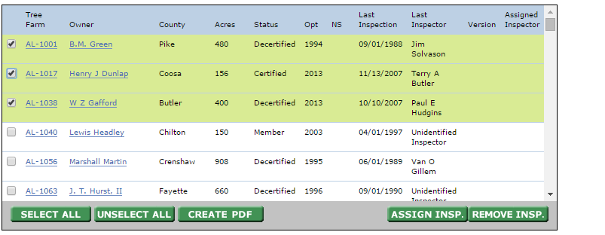
Method 2
- Log into ATFS database.
- Go to Print/Create inspection forms
- Enter the search criteria for the types of forms you are looking for. For example if you want to download all of the required inspections for that year your search criteria would be:
  - Tree Farm State= your state
  - Target year= current year
  - National/Optional= national
  - This would pull up the national sample for the year and you can download them all at once in a zip. If you wanted to download the optional samples that were designated for a year, then you would choose optional as your criteria
  - If you want to pull pre-populated forms for all of the properties that a certain person/organization owned then you would just search for that person/organization select all the results.
  - If you leave all of the search fields blank the results will display the first 250 Tree Farms in your state.
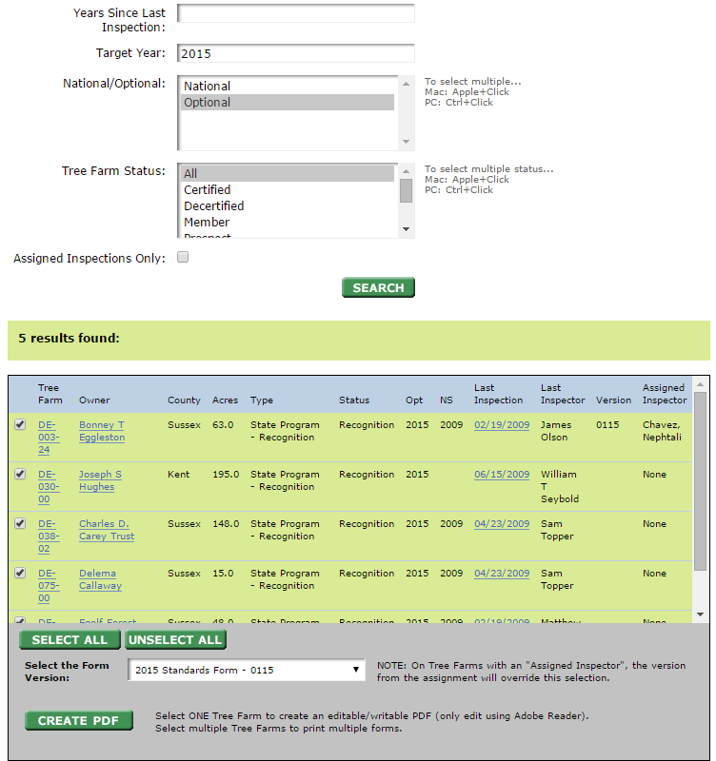
- The image below shows the 2015 optional inspections for Delaware. I searched for Target year 2015, Optional.
1
2

- Once the search results appear, Click select all, or the individual properties you need forms for.
- Click create PDF
- Save to your computer.
- Open the zip.

