How to change a Properties Tree Farm Number
The TF number for any property in the ATFS database can be changed at anytime to any unique alphanumeric combination. If the number is already in use, you will be prompted to use another number by the database to prevent duplication of Tree Farm numbers.
- Log into www.atfsdatabase.org
- Search for the Tree Farm whose number you want to change:
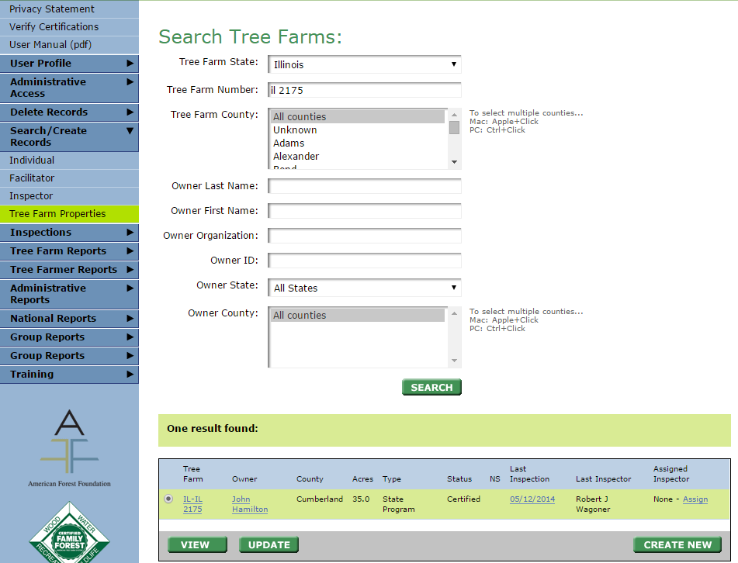
- Click the blue link with the tree farm number or you can also hit update (red box)
- A page will appear where you can change owners, you want to hit next.
- The next page will take you to TF number which can be adjusted
- You will get an error if you try to use a number that is already used. Once you change number, hit next and confirm your change. It is now changed in the databse.
