How to Assign Multiple Properties to One inspector
The ATFS database has the capability of selecting multiple Tree Farms to one inspector, but with the caveat that the Tree Farms all have to have something in common. This trait can be a common owner, common county, common previous inspector or that they are all tagged as required.
- Log into ATFS database.
- On the left side menu, click ‘Inspections’ then click ‘Assign inspector’
  - In the search fields, enter details for the type of properties you are looking for. For example, if you wanted to reassign a specific inspector to several properties in certain counties you’d search for all Tree Farms in those counties. To select multiple counties, hold the CTRL key and click the county names. Note: If you leave all of the search fields blank the results will display the first 250 Tree Farms in your state.
- The image below shows the results when searching for Tree Farms in 2 counties in Maine.
- Once the search results appear, select the Tree Farms you would like to assign the inspector to.
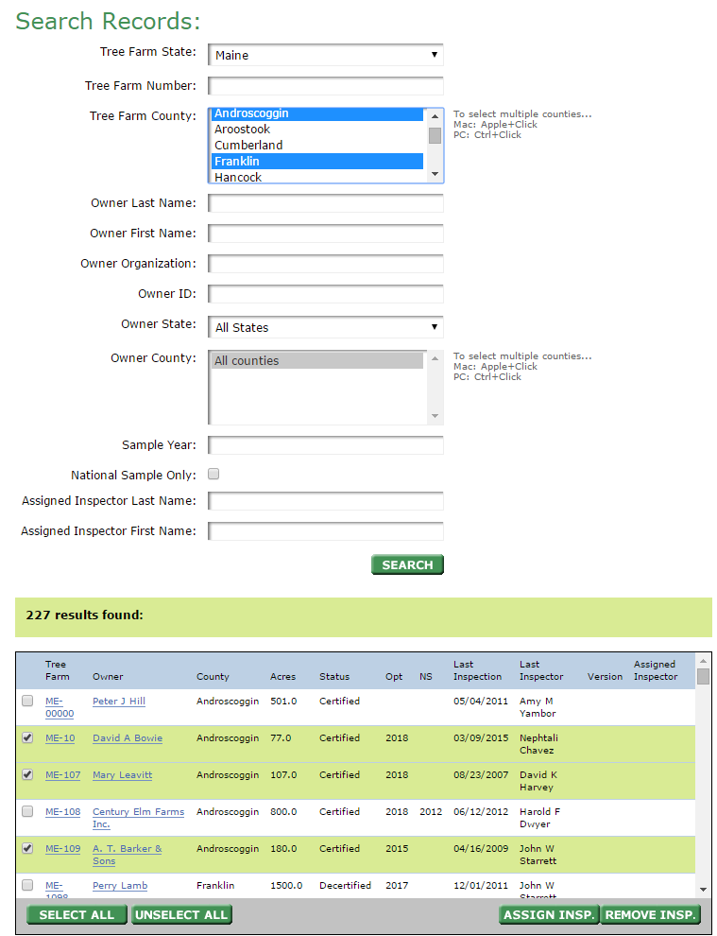
- A drop down list of inspectors will appear. Select the inspector and confirm your choice.
3
1
2

