How to Assign Inspections
Each ATFS inspection must be completed by a qualified inspector who has received the latest training and has had this training entered into the database. There is more than 1 way to assign an inspector a tree farm.
Method 1
- Under inspections, click on Assign Inspector
- Search for the Tree Farm you wish to be inspected with the available search fields.
- If multiple Tree Farms fit into your search criteria you will get multiple results, check off the Tree Farm(s) of interest.
- Click Assign Inspector in the lower right corner. If an inspector is already assigned to the property, remove that inspector by clicking Remove Inspector.
- A drop down list will appear with the names of eligible inspectors. Choose the appropriate name and click assign.
- Confirm your choice.
- Now you may create a pre-populated 004 form(s) for distribution.
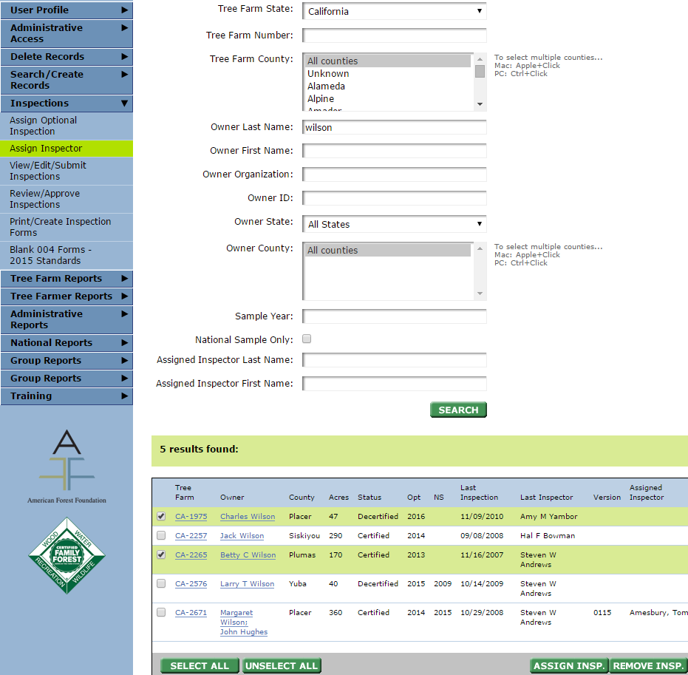
In this example, I am searching for a properties in California whose owners have the last name ‘Wilson’. This search has given me 5 results that I must choose from.
Tip: It’s easiest to find a property by its number.
2
1
Method 2
This method is quicker when assigning inspections one at a time. Method 1 allows you to assign multiple inspections to an individual at a time.
- Under Search/Create Records, select Tree Farm Properties
- Search for the Tree Farm of interest
- In the last column of your search results, you will see if the property is currently assigned. The inspector can be assigned by clicking the linked ‘Assign’ text. This will open a smaller window (make sure your pop up blocker isn’t preventing the new window from appearing).
- Choose from the eligible inspectors in the drop down list, click Assign and confirm your choice
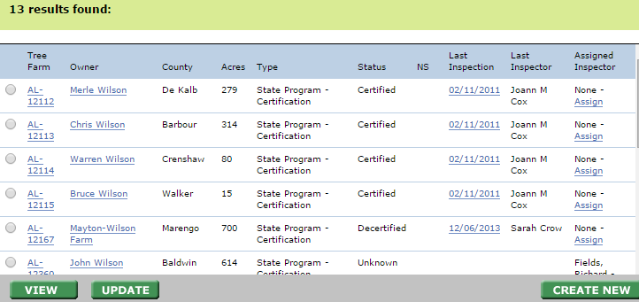

How to Assign Multiple Properties to One inspector
Multiple Tree Farms can be assigned to one inspector, BUT the Tree Farms all have to have a field in common in order for them to appear in the same search result. This field can be a common owner, county, previous inspector or that all are tagged as required inspections.
- Under ‘Inspections’ select ‘Assign inspector’
- Search for the properties you are looking for.
  - Example: You want to assign a specific inspector to properties in certain counties you’d search for all the Tree Farms in those counties. To select multiple counties, hold the CTRL key and click the county names.
  - Example 2: Searching by owner name would allow all properties owned by that person to appear and these can all be assigned to one inspector.
  - Note: If you leave all of the search fields blank the results will display the first 250 Tree Farms in your state.
- Select the Tree Farms you would like to assign the inspector to, click ‘Assign Inspector’ in the lower right.
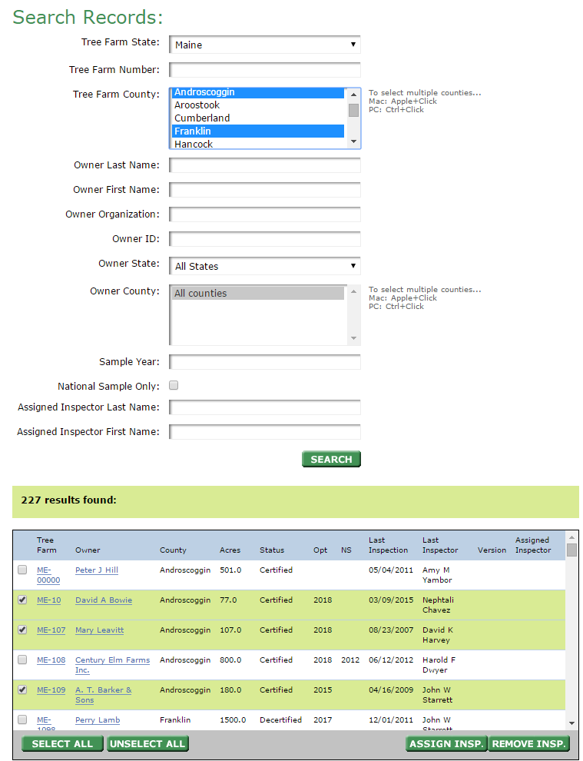
- A drop down list of inspectors will appear. Select the inspector and confirm your choice.
1
In this example, I am searching for properties that exist in certain counties of Maine. To select multiple counties, hold the CTRL key and click the counties.
3
2

